YUVA INTERN PROGRAM
TASK 4
SAP ABAP PERFORMANCE ANALYSIS
AND OPTIMIZATION
Practical implementation using SAP ECC 6.0 EHP7
Project information | Details
Internship | YUVA Intern – Task 4
Participant | Shashank Vangapalli
SAP environment | SAP ECC 6.0 EHP7
Development approach | Classic ABAP / classic Open SQL
Scenario | Sales-order header and item reporting
Programs | ZSD_ORDER_PERF_BEFORE and ZSD_ORDER_PERF_AFTER
Performance tools | ST05/SAT not used for final measurement
Prepared from practical execution screenshots and ABAP code analysis

TABLE OF CONTENTS
1. Executive Summary
2. Objective and Scope
3. Realistic Hypothetical Business Scenario
4. Data Model and Process Flow
5. Baseline Program – Before Optimization
6. Bottleneck Analysis
7. Optimized Program – After Optimization
8. Practical Implementation and Test Evidence
9. Performance Comparison – Code-Based Analysis
10. Validation and Test Cases
11. Best Practices and Further Improvements
12. Limitations and Honest Measurement Statement
13. Conclusion
Appendix A – Screenshot Register
Appendix B – Program Inventory

1. Executive Summary
This task investigates a common ABAP performance problem: executing a database SELECT statement repeatedly inside a loop. The practical example is a sales-order report that reads header information from VBAK and item information from VBAP. The original implementation first selects sales-order headers and then performs another SELECT on VBAP for each header. The optimized implementation retrieves the required header and item fields together using a classic Open SQL INNER JOIN. Both programs were created and executed in SAP ECC 6.0 EHP7, and screenshots show the original and optimized reports displaying sales-order item data.
The key finding is structural rather than a measured timing result. If N sales-order headers are selected, the original program can issue one header query plus N item queries. The JOIN version expresses the same relationship in one SQL statement, allowing the database to process the relationship as a set. This can reduce database round-trips and application-server/database communication. However, a JOIN is not automatically faster in every data volume or database configuration; actual runtime depends on indexes, selectivity, buffering, database optimizer decisions, network latency, and the size of the result set.
ST05 was opened during the exercise, but the captured trace contained unrelated SAP standard activity (including SOTR_TEXT) rather than a clean trace attributable to the Z report. Therefore, ST05 and SAT were not used to claim measured performance. No fabricated execution times, percentages, or SQL counts are included. The document distinguishes observed functional evidence from expected performance effects and recommends a controlled measurement as future validation.
The practical work is organized as a before-and-after comparison rather than as a theoretical discussion alone. The baseline report, ZSD_ORDER_PERF_BEFORE, follows a sequential retrieval pattern: it obtains the sales-document headers from VBAK and then retrieves the related item records from VBAP separately for each header. The optimized report, ZSD_ORDER_PERF_AFTER, uses an INNER JOIN on the common field VBELN and stores the selected header and item fields in one result internal table. Both reports display the same business-level information: sales document, document date, customer, item number, material, order quantity, and net value. This makes the example suitable for demonstrating how a change in database access design can preserve the report's purpose while reducing repeated database requests.
The central technical lesson is that database operations should generally be designed around sets of required records instead of issuing a new request for each row already read. If the first query returns N headers, the baseline source contains one header SELECT and up to N item SELECT statements. The JOIN implementation contains one joined SELECT in the ABAP source. Fewer request cycles can reduce communication overhead between the application server and database server, although the actual benefit depends on data volume, indexes, database optimizer decisions, system load, and the amount of data transferred. A JOIN is therefore a sound design improvement for this one-to-many reporting requirement, but it is not a guarantee of a specific runtime reduction.
The evidence in this submission has been deliberately separated into functional evidence and performance evidence. The screenshots show that the reports were executed and that item-level output was produced. The source code demonstrates that the repeated SELECT was removed. However, the ST05 trace captured during the exercise showed unrelated standard SAP activity, including SOTR_TEXT, and no clean trace attributable to either Z report was obtained. For that reason, no execution time, database time, SQL trace count, or percentage improvement is presented as a measured result. The outcome is a completed practical optimization with a clear code-level explanation and a defined plan for future SAT and ST05 validation.

2. Objective and Scope
The objective is to identify a realistic ABAP performance pitfall, explain why it causes unnecessary database work, implement a feasible optimization, and compare the original and optimized approaches. The scope is limited to reading sales-order header and item data for a user-selected order-date range. The programs are executable Z reports and use syntax suitable for the stated SAP ECC 6.0 EHP7 environment without modern Open SQL host-variable notation.
The task does not modify business data. Both reports are read-only and select fields from standard SAP tables VBAK and VBAP. The report output includes sales document number, document date, customer, item number, material, quantity, and net value. Authorization, data-volume limits, and production performance testing remain important considerations before adapting the example for a live business process.
The objective of this task is to recognize a performance-sensitive coding pattern, understand its effect on database communication, and implement a suitable alternative using the ABAP version available in the training environment. The specific problem selected is a SELECT statement placed inside a LOOP. This pattern is common in reports that first retrieve a group of parent records and then fetch related child records one parent at a time. It may work correctly for a small amount of data, but the number of database requests can increase in proportion to the number of parent records. The task therefore focuses on improving the data retrieval design without changing the business meaning of the report.
The functional scope is intentionally limited to a read-only sales-order item report. The user enters a start date and end date, and the report selects sales-document headers by VBAK-AUDAT. It then displays matching item details from VBAP. The fields used are VBAK-VBELN, VBAK-AUDAT, VBAK-KUNNR, VBAP-POSNR, VBAP-MATNR, VBAP-KWMENG, and VBAP-NETWR. The relationship is established through VBELN. No sales order is created, changed, deleted, billed, or otherwise updated by either program. This keeps the exercise focused on database retrieval and report output rather than transaction processing.
The technical scope includes two executable Z reports created in SE38, inspection of the standard table definitions in SE11, syntax checking, activation, execution, and comparison of the resulting lists. The code uses classic Open SQL syntax appropriate to SAP ECC 6.0 EHP7 and does not rely on newer host-variable notation. The exercise does not claim to cover every production concern. A live report would also require authorization checks, appropriate selection-screen restrictions, handling of very large result sets, transport and code review procedures, and performance testing with representative data. Those items are identified as considerations rather than claimed as completed implementation work.

3. Realistic Hypothetical Business Scenario
Consider a medium-sized electronics distributor that processes customer orders for laptops, monitors, accessories, and networking equipment. The sales operations team needs a daily or monthly report showing each sales order together with its line items, quantities, and net values. An analyst selects a date range, for example 01 January 1997 through 31 January 1997 in the training client, and expects a line-by-line report. In a real implementation the same logic could be used for a current business date range; the historical dates in the screenshots simply reflect the training system's available sample data.
The sales order header is stored in VBAK and contains information shared by the order, such as the document number, document date, and sold-to party/customer number. The order's individual products are stored in VBAP, where each item has its own item number, material, order quantity, and net value. One header can have several item rows. For example, a single order may contain a laptop, a wireless mouse, and a monitor. The report must therefore show the header values alongside each matching item row. This one-to-many relationship is the reason the program needs to combine VBAK and VBAP.
Table 1. Business requirements and their technical interpretation
Business requirement | Technical interpretation
Select orders by document date | Filter VBAK-AUDAT using a date range
Show customer and document number | Read VBAK-VBELN, VBAK-AUDAT, VBAK-KUNNR
Show every order item | Read VBAP-POSNR, MATNR, KWMENG, NETWR
Keep one row per item | Join VBAK and VBAP using VBELN
Handle invalid dates | Validate that start date is not later than end date
Handle no matching items | Display a clear no-records message

The hypothetical organization is a medium-sized electronics distributor that sells laptops, monitors, keyboards, networking devices, and other accessories to business customers. Its sales team enters customer orders in SAP, while the operations team periodically reviews order volume and item-level details. A supervisor may need to know which customer placed an order, when the order was created, which products were included, how many units were requested, and the net value of each line. A report that shows only the order header would not be sufficient because one sales order can contain several products. The business therefore needs a line-item report that repeats the header information for each corresponding item row.
For example, a customer order might contain one laptop, two monitors, and three wireless keyboards. SAP stores common order information once in the sales-document header and stores each product line separately. The report should show the same sales document number, document date, and customer number beside each of the three item records. This is not duplicate business data; it is the expected presentation of a one-to-many relationship in a line-item report. The analyst can then filter the report by a date interval and review the selected period without opening every sales order individually. In the training client, January 1997 was used because that is the historical sample data visible in the supplied screenshots. The date is a test input, not a recommendation for a current business report.
The scenario creates a practical reason to join VBAK and VBAP. VBAK contains the shared header attributes, while VBAP contains the product-specific attributes. The sales document number VBELN connects the two tables. The date restriction belongs to the header selection because the business requirement is to select orders according to their document date. The report must also handle operational exceptions: the user may enter an invalid date interval, or a valid interval may return no matching item records. A clear validation message and a no-records message make the report easier to use and prevent an empty result from being mistaken for a program failure. These requirements guide both the baseline and optimized implementations.

4. Data Model and Process Flow
VBAK is the sales-document header table and VBAP is the sales-document item table. The common key used in this example is VBELN. An INNER JOIN returns rows only when a matching header and item exist. Since the report is intended to list item-level sales data, this is appropriate: orders without any item rows are not included in the output. The date restriction is applied to the header date field AUDAT.
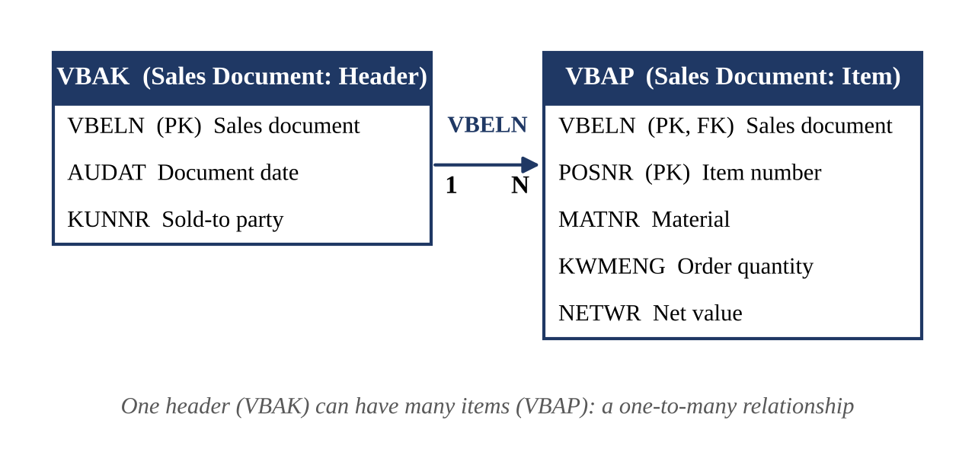
Figure 1. Data model: VBAK (header) and VBAP (item) are linked by the sales document number VBELN.
The two diagrams below contrast the access patterns. In the original design the item table is queried again for every header; in the optimized design a single set-oriented JOIN retrieves all matching header and item rows.
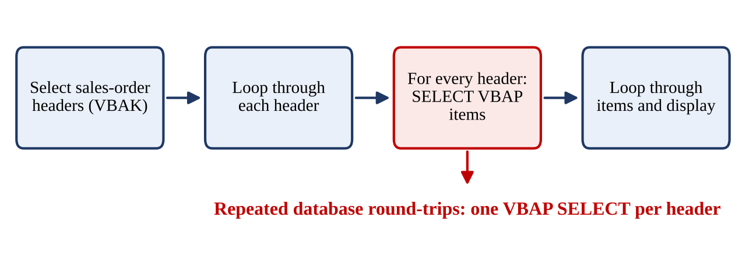
Figure 2. Original design: a VBAP SELECT is repeated for each selected VBAK header.
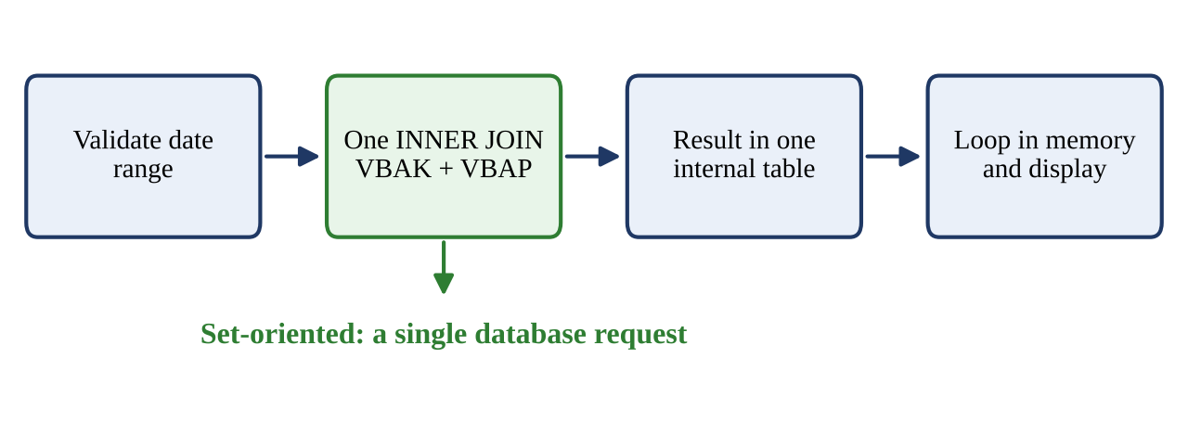
Figure 3. Optimized design: one set-oriented JOIN retrieves matching header and item data.
The data model consists of two standard SAP sales-document tables. VBAK is the header table and stores information that applies to the complete sales document, including VBELN, AUDAT, and KUNNR. VBAP is the item table and stores information specific to each line, including VBELN, POSNR, MATNR, KWMENG, and NETWR. The sales document number VBELN is the linking field. In business terms, one header can be associated with multiple item records, so the relationship is one-to-many. The diagram on page 5 represents this relationship by showing one VBAK record connected to several VBAP records. Understanding this structure is important before writing the SELECT statement because the join condition must use the correct common key.
The report applies the date filter to VBAK-AUDAT using the BETWEEN condition and the two selection parameters p_from and p_to. The condition limits the header records to the date interval supplied by the user. The INNER JOIN then combines each selected header with its matching item records. An INNER JOIN returns a row only when a matching record exists on both sides. This behavior is appropriate for the current requirement because the output is specifically a sales-order item report. A header without a matching VBAP item is not expected to produce a line in the result. If a future requirement asked for all headers, including those without items, the join type and output logic would need to be reconsidered rather than reused without analysis.
The process flow diagrams on page 5 illustrate the difference between the two designs. In the baseline flow, the program selects headers, loops over them, selects VBAP records for the current header, and then displays those items. The database access step is repeated for every header. In the optimized flow, the program validates the date range, executes one joined SELECT, stores the result in an internal table, and loops over the result only for display. The display loop remains necessary because the report must format each output row; the important change is that database retrieval is no longer performed inside that loop. The figures should therefore be read as a comparison of database access patterns, not as a claim that all looping has been eliminated.

5. Baseline Program – Before Optimization
The baseline report is named ZSD_ORDER_PERF_BEFORE. It first reads all matching header rows from VBAK into an internal table. It then loops over those headers and executes a separate SELECT against VBAP for the current sales document number. The item table is refreshed for each header, and the selected item rows are displayed. This code is easy to understand and can produce correct output, but the database access pattern becomes inefficient as the number of selected headers grows. The main concern is not the LOOP statement itself; the concern is placing a database SELECT inside that loop. Every iteration can cause another database request.
For example, if the date range returns 500 headers, the program may perform one SELECT for VBAK and up to 500 separate SELECT statements for VBAP. If it returns 5,000 headers, the number of item queries can grow to 5,000. This is commonly described as an N+1 query pattern. Each request has overhead, including ABAP/database interface processing and communication with the database. The exact cost depends on the system, but repeated database round-trips are a recognized performance risk. The issue becomes more significant when the selected date range is broad or the database is remote.
SELECT vbeln audat kunnr
INTO TABLE lt_header
FROM vbak
WHERE audat BETWEEN p_from AND p_to.

LOOP AT lt_header INTO ls_header.

REFRESH lt_item.

SELECT vbeln posnr matnr kwmeng netwr
INTO TABLE lt_item
FROM vbap
WHERE vbeln = ls_header-vbeln.

LOOP AT lt_item INTO ls_item.
WRITE: / ls_header-vbeln,
ls_header-audat,
ls_header-kunnr,
ls_item-posnr,
ls_item-matnr,
ls_item-kwmeng,
ls_item-netwr.
ENDLOOP.

ENDLOOP.
Code excerpt 1. Baseline pattern: SELECT from VBAP inside the header loop.
The baseline program is useful because it provides a working reference against which the optimized version can be checked. Its first SELECT reads the required header fields from VBAK for the chosen date range and places them in lt_header. The program then executes LOOP AT lt_header INTO ls_header. During each iteration, REFRESH lt_item clears the previous order's item rows, and a SELECT statement reads VBAP using the current header's VBELN. The returned item records are placed in lt_item and processed by a second loop. The WRITE statements combine the header work-area values with the current item work-area values to create one output line per item. This sequence is logically straightforward and demonstrates the relationship between header and item data.
The performance concern appears at the VBAP SELECT inside the outer loop. The first query is executed once, but the item query is executed again for every selected header. If 500 headers are returned, the source can issue one VBAK query followed by as many as 500 VBAP queries. If 5,000 headers are returned, the repeated item query may execute 5,000 times. This is known as an N+1 query pattern: one initial query is followed by N additional queries. Each database request has processing and communication overhead, even when an individual query returns only a few rows. The effect can become more noticeable when the database is remote or the selected date range is broad.
The REFRESH statement should not be treated as the primary defect. It clears lt_item before the next header is processed so that rows belonging to the previous order are not accidentally displayed again. Removing REFRESH without redesigning the retrieval logic could create incorrect output. Likewise, the LOOP statements themselves are not automatically inefficient; looping over an internal table for formatting is a normal report operation. The specific issue is issuing a database SELECT for each outer-loop record. The baseline program is retained as a comparison case because it makes this design weakness visible and provides a functional reference for checking the optimized output.

6. Bottleneck Analysis
The primary bottleneck is repeated database access inside LOOP AT lt_header. The program has already retrieved the list of headers, but it does not retrieve the corresponding item data in a single operation. Instead, it asks the database for the items of one order, processes them, then asks again for the next order. This creates an avoidable sequence of database calls. The code also uses REFRESH lt_item on every iteration. REFRESH is not the main performance problem here; it is needed to prevent item rows from the previous order remaining in the work table. Removing REFRESH without changing the logic could cause incorrect output. The correct optimization is to change the retrieval design, not simply delete a statement.
A second consideration is result-set size. The JOIN version places all selected item rows into one internal table. This reduces repeated SQL calls but may increase peak memory usage for very broad date ranges. For very large datasets, the report should consider additional selection criteria, package-wise processing, pagination, or a carefully designed streaming approach. Another consideration is field selection: both programs request only the fields needed by the report rather than using SELECT *. This is a good practice because unnecessary columns increase data transfer and memory consumption. Finally, an INNER JOIN excludes headers that have no matching items; this matches the line-item report requirement and should be documented as expected behavior.
Table 2. Potential issues, impact and recommended action
Potential issue | Why it matters | Action taken / recommendation
SELECT inside LOOP | Can create N additional database requests | Replace with JOIN
Unnecessary columns | Increases transfer and memory usage | Select only required fields
Very broad date range | Can produce a large internal table | Use selective date ranges and consider package processing
Incorrect result comparison | Could hide missing or duplicate items | Compare document/item keys and row counts
Unmeasured timing | Cannot substantiate a speed-up percentage | Do not claim measured gains without SAT/ST05 data

The main bottleneck is the repeated access to VBAP from within LOOP AT lt_header. The application server already has a list of selected sales-order headers, but it requests the related item records one order at a time. This creates a sequence of database calls instead of expressing the full header-to-item relationship in one set-oriented operation. The number of item queries grows as the number of headers grows. Even if each query is individually simple and uses the document number as a filter, the total overhead can become significant when the report processes many orders. This is why code review should pay particular attention to database statements placed inside loops, especially loops whose number of iterations depends on business data volume.
There are several related considerations. First, the baseline refreshes the item table on each iteration; this is necessary for correctness in the current design and is not the main bottleneck. Second, the optimized JOIN collects all matching rows into one internal table. That can reduce request cycles but may increase the amount of memory required at one time, especially for a very broad date range. Third, selecting unnecessary columns increases data transfer and memory use, so both reports should request only the fields needed for output. Fourth, an INNER JOIN excludes headers without matching items. That is consistent with the stated item-level report requirement, but it must be considered if the business requirement changes.
The recommended action is to change the data retrieval design rather than make superficial changes to the loop. The JOIN approach retrieves the required fields together and removes the repeated VBAP SELECT from the header loop. For very large datasets, the developer should also consider restricting the selection range, processing records in packages, or using another controlled approach that avoids loading an excessive result set into memory. These options must be tested against the business requirement. Adding a filter merely to reduce volume is not acceptable if it removes valid business records. A good performance improvement must reduce unnecessary technical work while preserving the expected report contents.

7. Optimized Program – After Optimization
The optimized report is named ZSD_ORDER_PERF_AFTER. It uses a classic Open SQL INNER JOIN between VBAK and VBAP on the shared sales document number VBELN. The date-range condition is applied to VBAK-AUDAT. The selected header and item fields are transferred directly into one internal table. The program then loops over that internal table only to format and display the result. The database SELECT is no longer executed inside a loop.
This is a set-oriented approach: instead of asking the database repeatedly for the items belonging to individual headers, the program describes the complete relationship in one SQL statement. The database optimizer can choose an execution plan for the join and apply the date condition while retrieving matching rows. This normally reduces the number of ABAP-to-database request cycles. The program also validates the date range before accessing the database and checks whether the result table is initial before attempting to display records. The final output is item-level, so a sales order with four items appears on four rows with the header values repeated for each item. The expected benefit is fewer SQL requests and potentially lower elapsed time, particularly as the number of selected orders increases; however, this is an expected effect, not a measured result in this exercise.
SELECT a~vbeln a~audat a~kunnr
b~posnr b~matnr b~kwmeng b~netwr
INTO TABLE lt_result
FROM vbak AS a
INNER JOIN vbap AS b
ON a~vbeln = b~vbeln
WHERE a~audat BETWEEN p_from AND p_to.

IF lt_result IS INITIAL.
WRITE: / 'No sales order items found'.
ELSE.
LOOP AT lt_result INTO ls_result.
WRITE: / ls_result-vbeln,
ls_result-audat,
ls_result-kunnr,
ls_result-posnr,
ls_result-matnr,
ls_result-kwmeng,
ls_result-netwr.
ENDLOOP.
ENDIF.
Code excerpt 2. Optimized pattern: one INNER JOIN followed by an in-memory display loop.
The optimized report, ZSD_ORDER_PERF_AFTER, replaces the repeated per-header item query with a classic Open SQL INNER JOIN. VBAK is assigned the alias a and VBAP is assigned the alias b. The join condition a~vbeln = b~vbeln connects the sales-document header to its item records. The WHERE condition applies the selected date interval to a~audat. The SELECT list contains only the fields required by the report: document number, date, customer, item number, material, quantity, and net value. The INTO TABLE clause transfers the joined result into lt_result. This design allows the database to process the relationship as a set rather than requiring the ABAP program to request item data separately for each header.
After retrieval, the program checks IF lt_result IS INITIAL. If no matching item rows were found, it displays a clear message. Otherwise, it loops over lt_result and writes the selected fields. This loop is an in-memory processing step used to format the output; it does not execute another database SELECT. A sales order with multiple items therefore appears on multiple output lines, with the header fields repeated beside each item. That is the expected line-item presentation and preserves the purpose of the baseline report. The optimized program also validates the date range before database access so that an invalid interval can be rejected early.
The expected advantage is a reduction in ABAP-to-database request cycles because the source contains one joined SELECT instead of a header SELECT followed by a VBAP SELECT for every header. The database optimizer determines the actual execution plan, and the result depends on table statistics, indexes, selectivity, system load, and result-set size. Therefore, the JOIN is a reasonable optimization for this scenario, but it must still be tested with representative data. The implementation uses classic Open SQL syntax so it remains aligned with the stated ECC 6.0 EHP7 environment. It does not rely on newer syntax that may not be supported in the training system.

8. Practical Implementation and Test Evidence
The implementation was carried out in SAP ECC 6.0 EHP7 using SE38. Two executable Z programs were created: ZSD_ORDER_PERF_BEFORE and ZSD_ORDER_PERF_AFTER. The Dictionary definitions of VBAK and VBAP were checked in SE11 before coding. Both programs were saved, syntax-checked, activated, and executed. The same selection parameters were used for the practical comparison. The training client returned sales-order records dated in January 1997, including documents 4969 through 4977 in the visible output.
The supplied screenshots show the original selection screen and original list output, as well as the optimized report output. The optimized output visibly contains document number, date, customer, item, material, quantity, and net value columns. The displayed records include multiple items for the same document, such as document 4970 and document 4974, which is consistent with the one-to-many header/item relationship. The screenshots support successful execution and functional output. They do not by themselves prove a runtime improvement, because no controlled runtime measurements were captured.
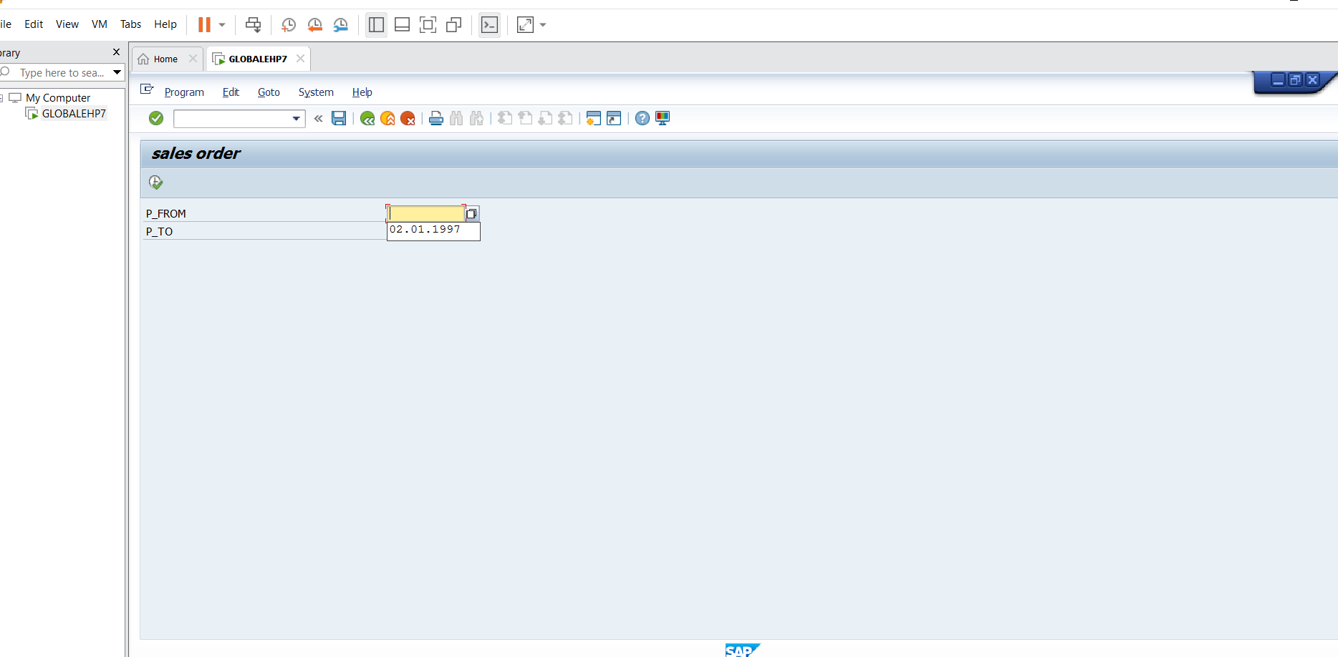
Figure 4. Original report selection screen in SAP GUI.
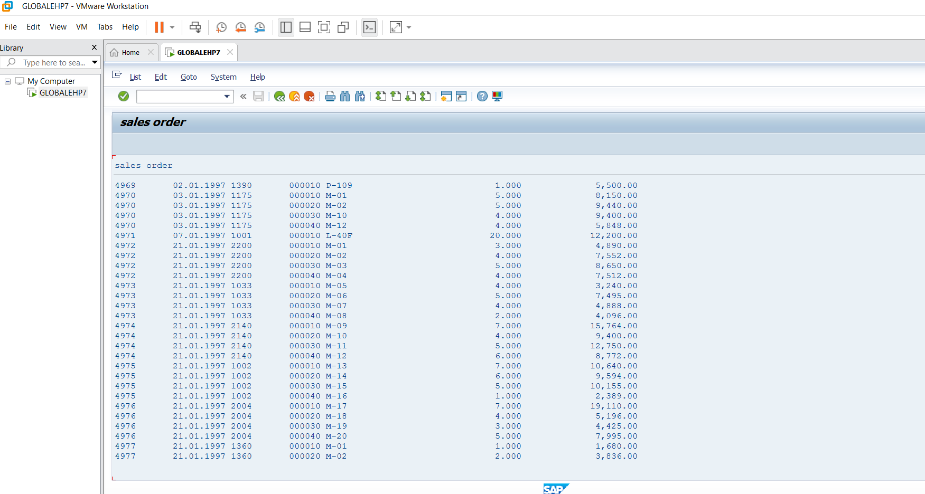
Figure 5. Baseline report output showing sales-order header and item information.
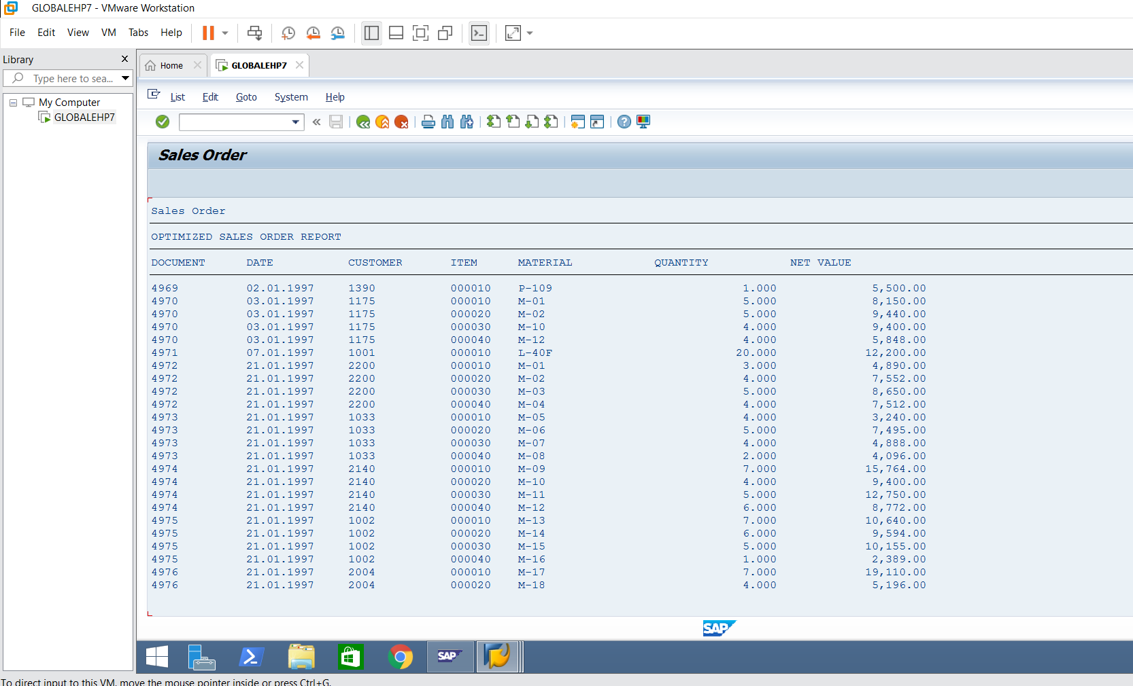
Figure 6. Optimized report output using the INNER JOIN implementation.
The practical implementation was completed in SAP ECC 6.0 EHP7 using transaction SE38. Before writing the report logic, the standard table definitions were inspected in SE11 to confirm the relevant fields in VBAK and VBAP. Two executable Z programs were created: ZSD_ORDER_PERF_BEFORE for the baseline logic and ZSD_ORDER_PERF_AFTER for the JOIN-based logic. Each program was saved, checked for syntax errors, activated, and executed. The same date selection was used so that the two reports could be compared under the same functional conditions. This sequence is important because comparing programs with different selection criteria would not provide a meaningful comparison of their output.
The screenshots included in the document provide evidence of the practical steps and report results. Figure 4 on page 9 shows the original report selection screen. Figure 5 shows the baseline list output, and Figure 6 on page 10 shows the optimized report output. The visible output contains the sales document, date, customer, item, material, quantity, and net value information. Multiple rows for the same document, including examples such as documents 4970 and 4974, demonstrate that the report displays individual item records rather than collapsing the order into a single header row. The training client returned historical January 1997 sample records, including visible documents in the range 4969 through 4977.
The screenshots establish that the reports were created and executed and that the optimized program produced the intended item-level output. They are functional evidence, not proof of a runtime improvement. A screenshot cannot establish database execution time, number of SQL calls, or application-server processing time. For a complete performance test, the developer would need a clean trace for each Z program and comparable measurements using the same input range. The implementation evidence should therefore be interpreted carefully: the practical coding and output steps were completed, while controlled performance measurement remains a future activity. This distinction makes the report more reliable because it does not claim results that the captured evidence cannot support.

9. Performance Comparison – Code-Based Analysis
Because ST05 and SAT were not completed with a clean trace for the Z programs, this report does not present measured execution times or measured percentage improvements. Instead, the comparison below describes the SQL access pattern visible in the source code. In the baseline, the number of SELECT statements is approximately 1 + N, where N is the number of headers returned by the first query, assuming the loop reaches every header. In the optimized source, there is one joined SELECT statement in the ABAP code. The database may internally execute a more complex plan, but from the ABAP program's perspective the repeated per-header SELECT statements have been removed.
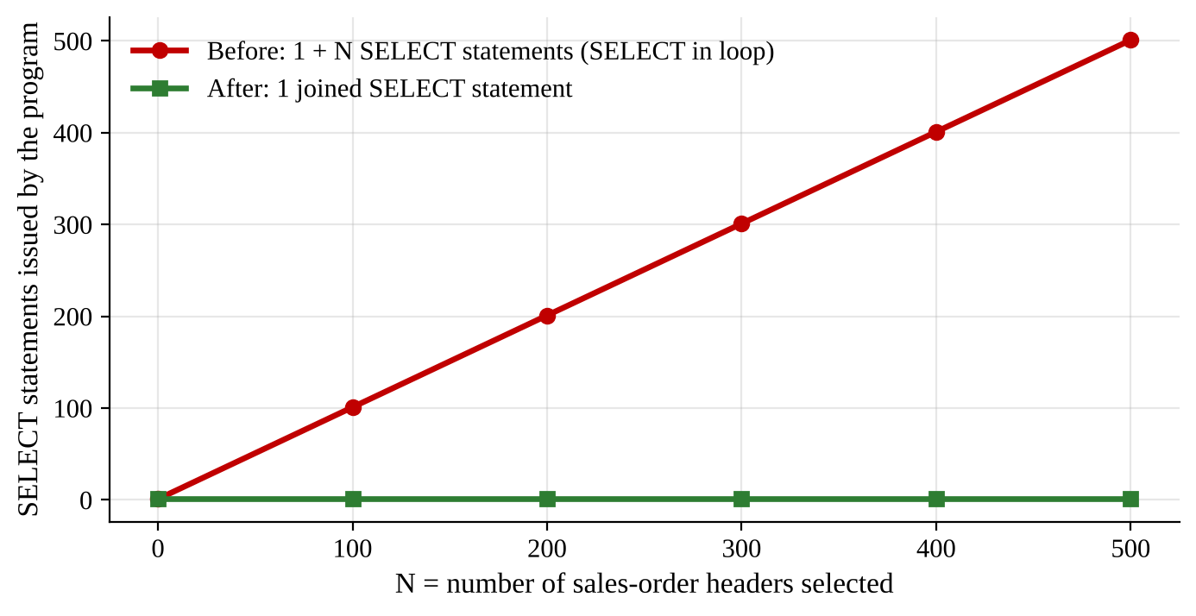
Figure 7. Number of SELECT statements issued by each program as N grows (derived from the source code; not a timing measurement).
This is a defensible code-level finding. It is not valid to convert it into a claimed time reduction such as 70% or 90% without measuring the same dataset under comparable conditions. To measure later, run each report several times with the same date range and comparable system load. Use SAT for ABAP runtime analysis and ST05 for SQL trace. Record elapsed time, database time, number of SQL executions, and rows transferred. Ignore the first run if it is affected by initial loading or caching, or report warm and cold runs separately. Also verify that the outputs contain the same document/item key combinations before comparing speed.
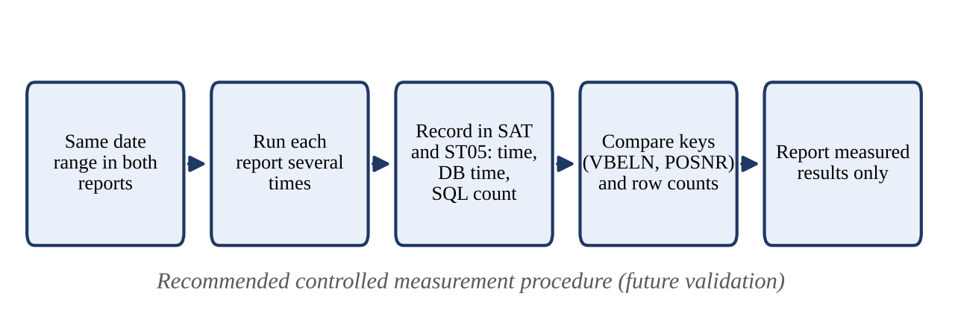
Figure 8. Recommended procedure for a controlled performance measurement.
Table 3. Code-based comparison of the before and after programs
Comparison point | Before program | After program | Evidence status
Database access structure | Header SELECT + item SELECT in loop | Single JOIN SELECT | Confirmed from source code
Potential SQL request count | 1 + N | 1 joined SELECT statement in ABAP | Code-based expectation
Repeated VBAP query per header | Yes | No | Confirmed from source code
Output granularity | One row per item | One row per item | Observed in screenshots
Elapsed time | Not measured | Not measured | Not available
Percentage improvement | Not calculated | Not calculated | Must not be invented

The comparison in this task is based on the SQL statements visible in the two ABAP source programs. In the baseline report, one SELECT reads the headers from VBAK. The program then enters the header loop and executes a VBAP SELECT for each header. If N headers are returned and every header is processed, the source-level query pattern is approximately 1 + N SELECT statements. In the optimized report, the ABAP source contains one joined SELECT statement that retrieves the matching header and item fields. The later LOOP processes the internal table for display and does not issue another database request. This is a structural comparison of the program code and is the basis for the graph on page 10.
The graph illustrates how the potential number of SELECT statements in the baseline increases as N grows, while the optimized source retains one joined SELECT statement in the ABAP code. The graph is derived from the source structure; it is not a measured runtime chart. It does not show seconds, database time, CPU utilization, or a measured speed-up percentage. A database may internally perform multiple operations as part of a JOIN execution plan, so the phrase one SELECT refers to one SQL statement in the ABAP source and not necessarily one low-level database operation. This distinction prevents the graph from being misunderstood as a complete database execution profile.
A controlled measurement should be performed before making a quantitative performance claim. The same input range should be executed for both reports several times under comparable system conditions. SAT can be used to analyze ABAP runtime, while ST05 can capture SQL trace information. Useful measurements include total elapsed time, database time, number of SQL executions, rows returned, and the time spent in relevant program sections. Initial runs affected by loading or caching should be treated separately from repeated warm runs. The result rows should also be compared using VBELN and POSNR to confirm that both programs return the same item-level data. Until this process is completed, the defensible conclusion is that the optimized source removes repeated per-header SELECT statements, not that it achieved a particular percentage improvement.

10. Validation and Test Cases
Functional validation is necessary because an optimization that runs faster but changes the report's business meaning is not acceptable. The same date range should be entered in both programs. Compare each result using the compound key VBELN + POSNR, because a sales document can contain multiple item rows. Check that the item count and the values for each key match. Also test an empty date range and an invalid range where the start date is later than the end date. The program should show a clear message for no matching items and reject an invalid date interval before running the database query.
Table 4. Test cases for functional validation
Test case | Input / action | Expected result
Normal data | Use date range containing sales orders | Both reports display matching item rows
Multiple items | Select a document with multiple VBAP rows | One output row per item
No matching data | Choose a date range with no orders | No-records message
Invalid range | Start date later than end date | Error message; no SELECT executed
Large date range | Use a broad date interval in a test client | JOIN returns results; assess memory and runtime before production use

Functional validation is required because a performance optimization is useful only when it preserves the required business result. Both programs should be executed with the same start date and end date. The output should be compared at item level using the combined key VBELN and POSNR. VBELN alone is not sufficient because one sales document can contain several items, and each item must be checked independently. For every key, compare the selected header and item values, including date, customer, material, quantity, and net value. The total number of item rows should also be checked. This comparison helps identify missing records, duplicate rows, or incorrect joins that may not be obvious from a quick visual review.
The normal-data test uses a date interval known to contain sales orders. Both reports should display matching item rows. The multiple-item test focuses on an order that has more than one VBAP record; the expected result is one output row for each item, with the header values repeated. The no-data test uses a valid date interval with no matching sales-order items and should result in the optimized program's no-records message rather than an empty or confusing display. The invalid-range test enters a start date later than the end date. The report should reject the interval before running the database query, because executing a query with invalid user input wastes work and can confuse the user.
A large-date-range test is also important. A broad interval may return many item rows, and the JOIN result can occupy substantial memory because it is collected in lt_result. The developer should observe whether the report remains usable and whether the system has sufficient resources. If the dataset is too large, a narrower selection or package-based processing strategy may be needed. Test results should be recorded with the input values, expected outcome, actual outcome, and any issue found. These checks establish functional correctness separately from runtime performance. Passing the functional tests confirms that the report behaves as required; it does not by itself prove that the optimized version executes faster.

11. Best Practices and Further Improvements
The example demonstrates one important performance rule: avoid database SELECT statements inside loops when the required data can be fetched set-wise. Other practices should also be applied. Select only the required columns rather than using SELECT *. Use selective WHERE conditions so the database processes fewer rows. Use internal table types appropriate to the access pattern; if repeated key lookups are required in a later design, a SORTED or HASHED table may be more suitable than repeated linear searches in a standard table. Do not introduce nested loops over large internal tables without considering algorithmic complexity. Validate inputs before database access and handle empty results explicitly.
For production-grade reporting, the JOIN should be tested with realistic data volumes and the database execution plan should be checked using the system's approved performance tools. If the result set is very large, consider package-wise processing or narrower selection criteria to control memory usage. Any additional filters should preserve business semantics and be based on the functional requirement. For example, filtering by sales organization may reduce data volume if the business report is intended for one sales organization, but adding that filter without a requirement would change the report's meaning. Performance tuning must not silently alter the business result.
The first best practice demonstrated by this task is to avoid database SELECT statements inside loops when the required records can be retrieved together. A developer should inspect loops that contain SELECT, SELECT SINGLE, or other database access and determine whether the data can be fetched before the loop through a JOIN or another set-oriented operation. This does not mean every SELECT inside every loop is automatically wrong; there may be cases where the next query depends on a value that cannot reasonably be collected in advance. The developer should evaluate the number of iterations, the amount of data, and the database access pattern before deciding. In this scenario, the header and item relationship is known in advance, so a JOIN is appropriate.
Other good practices include selecting only required columns instead of using SELECT *, applying selective WHERE conditions, validating user input, and handling empty result tables explicitly. Narrow and meaningful filters reduce the number of rows processed and transferred. Internal table type should also match the later access pattern. If a future program repeatedly looks up rows by key, a SORTED or HASHED internal table may be more suitable than repeated linear searches in a standard table. Nested loops over large internal tables should be reviewed because their processing cost can grow quickly as the data volume increases. These choices should be made according to actual requirements rather than added without a reason.
Further improvements for a production report would include authorization checks, realistic volume testing, clear selection-screen restrictions, and a suitable output technology such as ALV if interactive sorting, filtering, and totals are required. The JOIN should be examined with the approved performance tools and realistic database statistics. If a broad selection creates an excessively large result table, package-wise processing or more restrictive business filters may be appropriate. Any new filter must be approved by the functional requirement; for example, adding a sales-organization filter is valid only if the report is intended to show one sales organization. Performance tuning must not silently remove valid records or alter the meaning of the report.

12. Limitations and Honest Measurement Statement
The SAP ST05 screen was opened during the exercise, but the captured trace displayed unrelated SAP standard activity, including a SELECT from SOTR_TEXT. It did not provide a clean, attributable trace for ZSD_ORDER_PERF_BEFORE or ZSD_ORDER_PERF_AFTER. The user chose to skip the detailed ST05/SAT measurement process. Consequently, this submission reports actual program execution and code-level SQL pattern analysis only. No runtime values, database time values, SQL counts from a valid Z-program trace, or percentage improvements are claimed.
This limitation does not invalidate the coding exercise: the repeated SELECT inside the loop is visible in the original source, and its replacement by an INNER JOIN is visible in the optimized source. However, a formal claim that the optimized program is faster must be supported by controlled measurements. The next improvement to this task would be to capture a clean SAT and ST05 trace for each program using identical selection criteria and compare multiple runs.
The main limitation of this exercise is that a clean performance trace for the two Z reports was not captured. ST05 was opened and the trace screen was inspected, but the captured activity showed unrelated SAP standard processing, including a SELECT involving SOTR_TEXT. That trace could not be reliably attributed to ZSD_ORDER_PERF_BEFORE or ZSD_ORDER_PERF_AFTER. A trace containing unrelated activity cannot be used to calculate the SQL count or database time of the report. SAT was also not completed as a controlled comparison. As a result, this document does not include measured elapsed times, database times, SQL execution counts from a valid trace, or percentage improvements.
This limitation should be stated clearly because code inspection and runtime measurement answer different questions. Source-code analysis confirms that the baseline contains a SELECT inside the header loop and that the optimized program replaces it with an INNER JOIN. This establishes a change in the database access structure. It supports the expectation that repeated application-server-to-database request cycles have been removed from the ABAP logic. It does not prove the exact runtime benefit on the training system. Actual execution can be influenced by database indexes, optimizer choices, table statistics, caching, network conditions, system workload, and the number of records returned. A JOIN can also require more memory if a very large result set is loaded into one internal table.
The next step is to perform a controlled measurement. Run both programs with identical selection criteria and comparable system load. Use ST05 to filter and trace the relevant Z program activity, and use SAT to analyze ABAP runtime. Repeat the runs and record the measurement conditions so that results can be reproduced. Compare the SQL execution pattern, database time, total runtime, and returned row count. Before comparing performance, verify that the two outputs contain the same VBELN and POSNR combinations. Until those measurements are available, the report should present the optimization as a code-level improvement with functional execution evidence. This honest statement is more technically credible than inserting unsupported timing figures.

13. Conclusion
This task examined a common SAP ABAP performance issue: executing a database SELECT statement repeatedly inside a loop. The practical scenario was a sales-order item report for an electronics distribution business. The report needed to display the sales document number, document date, customer, item number, material, order quantity, and net value for a user-selected date interval. The required information is stored in two related standard SAP tables. VBAK contains sales-document header information, while VBAP contains item-level information. The common field VBELN connects the two tables, and one header can have several item records. Understanding this one-to-many relationship was essential before designing the report and its optimization.
The baseline program, ZSD_ORDER_PERF_BEFORE, first selects matching headers from VBAK and stores them in an internal table. It then loops through those headers and executes a separate SELECT against VBAP for each sales document. Although this approach can produce correct output, it creates an N+1 query pattern: one initial header query followed by up to N item queries for N selected headers. As the number of orders increases, the number of database requests also increases. Each request can introduce database-interface processing and communication overhead. The REFRESH statement in the baseline is required to clear the previous order's item rows; it is not the main performance problem. The actual issue is placing the database SELECT inside the outer LOOP.
The optimized program, ZSD_ORDER_PERF_AFTER, addresses this issue by using a classic Open SQL INNER JOIN between VBAK and VBAP. The join condition uses the common field VBELN, and the date restriction is applied to VBAK-AUDAT. Only the fields required for the report are selected into one result internal table. The program then loops over that table only to display the records. Therefore, the optimized version still uses a LOOP for output formatting, but it no longer performs a separate database SELECT for every header. This set-oriented design expresses the header-and-item relationship in one SQL statement in the ABAP source and is expected to reduce repeated ABAP-to-database request cycles.
The practical implementation was completed in SAP ECC 6.0 EHP7 using SE38, after checking the standard table fields in SE11. Both executable Z reports were saved, syntax-checked, activated, and executed. The screenshots show the selection screen and the baseline and optimized outputs. The visible results contain item-level rows, including multiple rows for the same sales document, as expected from the relationship between VBAK and VBAP. The training client displayed historical January 1997 sample data. These screenshots confirm program execution and functional output; they do not, by themselves, prove a runtime improvement.
The performance comparison was therefore kept at the code-analysis level. The baseline source has an approximate SELECT pattern of 1 + N, while the optimized ABAP source contains one joined SELECT. ST05 was opened, but the captured trace showed unrelated SAP standard activity, including SOTR_TEXT, and was not a clean trace for either Z report. SAT/ST05 measurements were not completed, so no execution times or percentage improvements are claimed. A future controlled test should run both reports with identical selection criteria, repeat the runs under comparable system conditions, capture SAT runtime and ST05 SQL information, and compare output using VBELN and POSNR. Overall, the task demonstrates a technically appropriate code-level optimization and functional validation while clearly identifying formal performance benchmarking as the next step.

Appendix A – Screenshot Register
Table 5. Register of captured screenshots
Evidence | Description | Use in report
Screenshot 2026-11-10 185122.png | Original report selection screen | Shows date parameters
Screenshot 2026-11-10 185234.png | Original report output | Baseline functional output
Screenshot 2026-11-10 214535.png | Optimized report output | Optimized functional output
Screenshot 2026-11-10 215308.png | ST05 filter conditions | Shows trace filter screen; not used as performance evidence
Screenshot 2026-11-10 215915.png | SQL Trace Record detail showing SOTR_TEXT | Unrelated standard-table trace; excluded from performance claims

Appendix B – Program Inventory
Table 6. Program inventory
Program | Purpose | Key technique
ZSD_ORDER_PERF_BEFORE | Baseline sales-order item report | SELECT inside LOOP
ZSD_ORDER_PERF_AFTER | Optimized sales-order item report | VBAK–VBAP INNER JOIN

